Lab 5

Volumes exist on Elastic Block Storage (EBS) when an instance (AMI) is created. Volumes are essentially virtual hard disks. Snapshots exist on Simple Storage Service (S3) and they are created from volumes. A snapshot is a copy of a volume at a particular moment in time.

Part I: Linux – Volumes and Snapshots
- Login to your AWS account as IAM user, NOT root user.
- Select region: “US West (Oregon) us-west-2”
- Launch an Amazon Linux (free tier eligible) EC2 instance, name it as: EBS_Lab
(note: make sure to enable SSH as defaults)
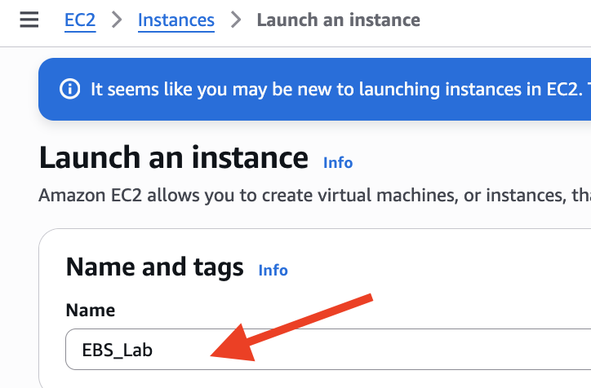
- Wait till the EC2 instance is “running”
- Examine the volume that gets created as part of the process of creating an instance.
On the left side of the EC2 Dashboard, under ELASTIC BLOCK STORE, select Volumes.

  - Under the column Attachment Information, locate the Instance ID of your running Linux instance.
  - Write down the name of the device. Example: /dev/sda1 or /dev/xvda
  - Click the Description tab. In what Availability Zone is your volume located? Is it encrypted?
  - Name your volume. I called mine “EBS_Lab”
- Go back to Volumes dashboard.

- Create a new volume using Create volume button on the top-right corner of the screen.
  - Select “Magnetic(standard)” as the Volume Type.
  - Set the size to 5 GiB.
  - Make sure the volume is created in the same Availability Zone as your AMI.
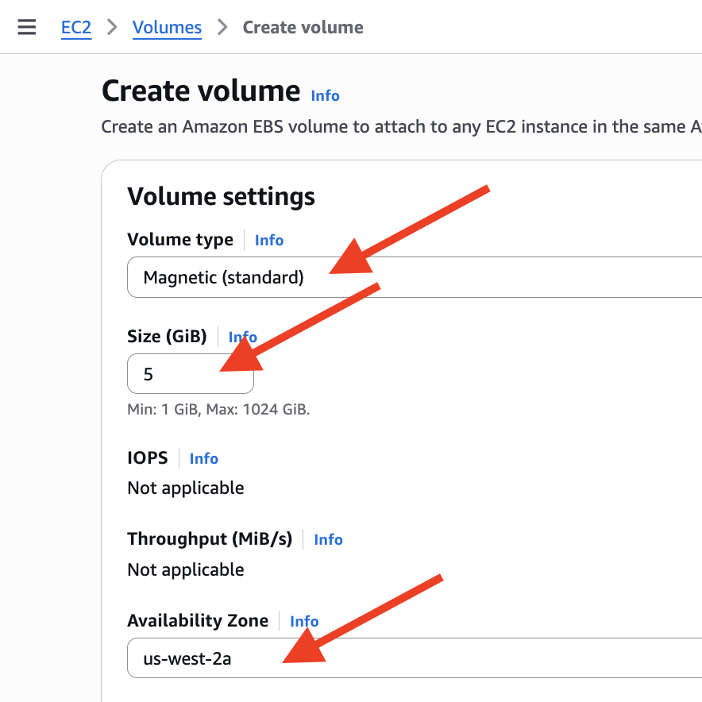
- Once the volume has been created, give it a label. I called mine “New Linux Volume”.
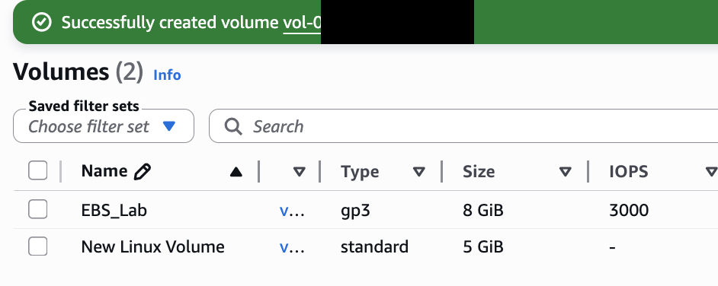
- Attach the new volume to Linux instance.
  - Click the checkbox next to the new magnetic volume you’ve just created.
  - Click the Actions button and select “Attach volume” option.
(If you don’t see “Attach volume”, refresh your web page)
  - Click in the Instance dropdown and you should see your running EC2 instance.
  - Select your EC2 and select “/dev/sdf” value in the Device name field.
  - Click orange Attach volume button to proceed.
- Go back to your “Instances” dashboard. Select your Linux instance, Click on the “Storage” tab for your instance. Notice that you have a new block device associated with your instance.
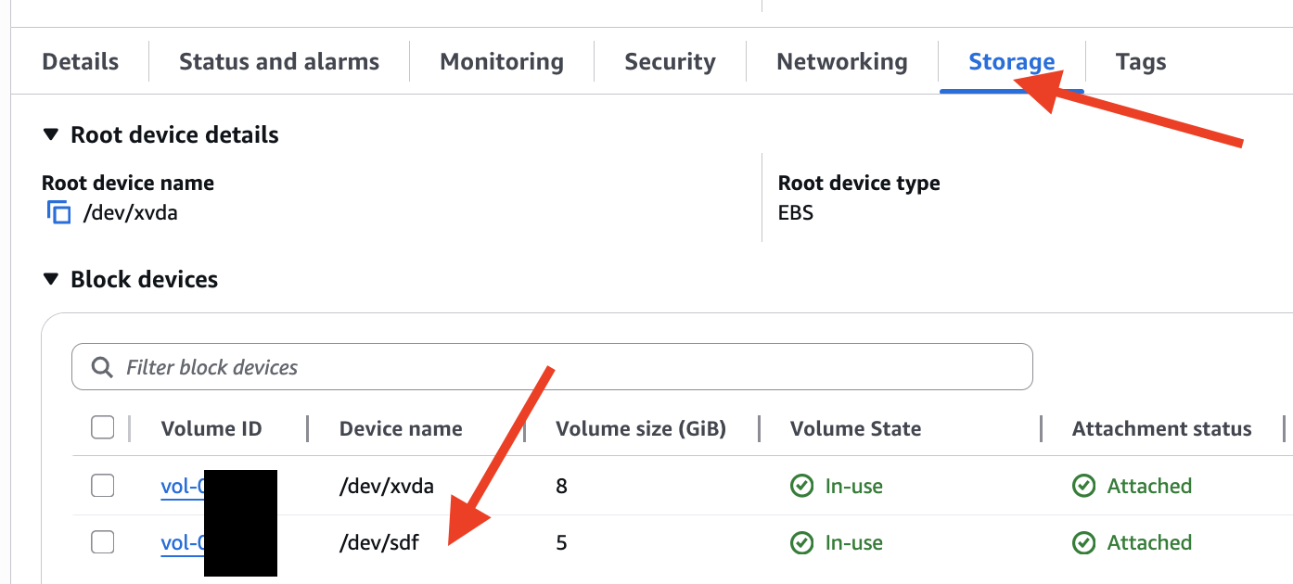

- Mount the new drive (volume) on your Linux instance and format it.
  - Log into the instance using SSH.
  - Remember: The username (login as) is “ec2-user”
  - Change to root user: “sudo -s”
  - Run the “lsblk” command to find your device name (it’s the one at the bottom)
(mine is named nvme1n1) Hint: the one with size 5G
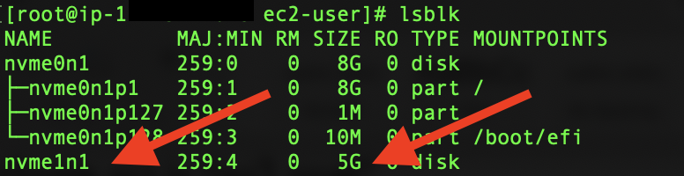
  - Check for data on new volume: “file -s /dev/your_device_name”
Mine is file -s /dev/nvme1n1
    - The volume name “nvme1n1” might be different on your instance.
  - Create a file system on the new volume: “mkfs -t ext4 /dev/nvme1n1”
  - Make a directory for as a mount point for the volume: “mkdir /fileserver”
  - Verify the new directory got created: “ls /”
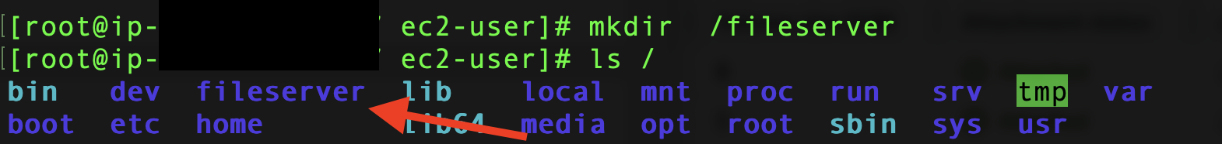
  - Mount the new volume to the directory: “mount /dev/nvme1n1 /fileserver”
  - Navigate in to the directory: “cd /fileserver”
  - Perform a file listing: “ls”
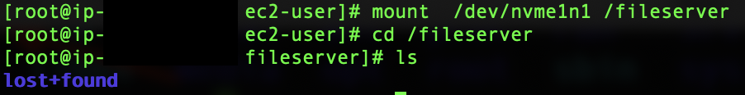
  - Create a couple of files on the new volume:
    - “touch helloworld.txt”
    - “touch index.html”
    - Perform a file listing (ls) to verify your files were created.
    - NEVER DELETE THESE FILES!
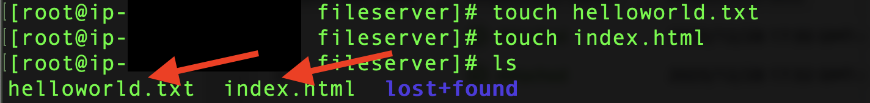
  - Navigate to the root directory of the root user: “cd /”
  - Now, unmount the volume: “umount /dev/nvme1n1”
    - No letter ‘n’ in ‘umount.’ (It’s ‘u-mount’, NOT ‘un-mount’)
  - Then, “cd /fileserver” and perform an “ls”
    - Are your files still there? Why or why not?
- Go back to AWS Console and navigate to the Volumes screen.
  - Click the checkbox next to the volume you created earlier (“New Linux Volume”)
  - From the Actions button, select “Detach volume”.
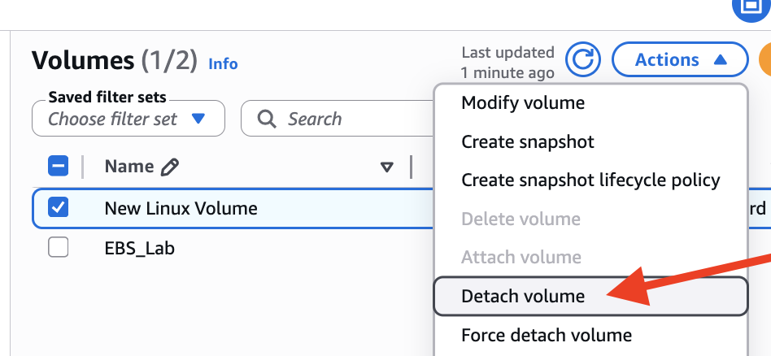
  - Click Detach button to confirm.
  - Verify the volume has been detached by looking the Storage tab of your instance.
Notice that the block device is no longer attached to the instance.
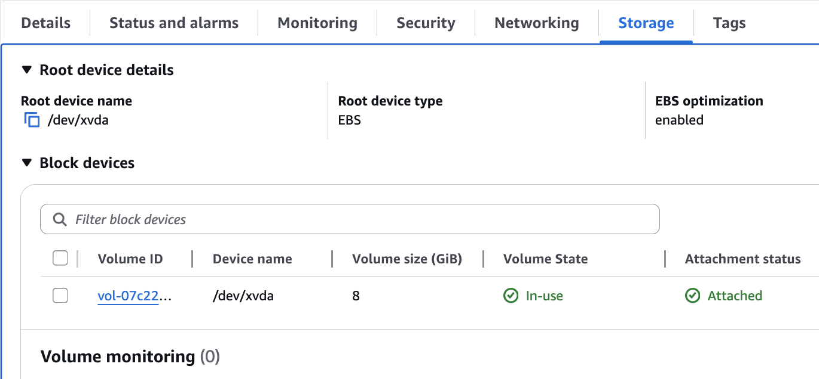
- Create a Snapshot of the detached volume.
  - Click the checkbox next to the volume.
  - From the Actions button, select “Create snapshot.”
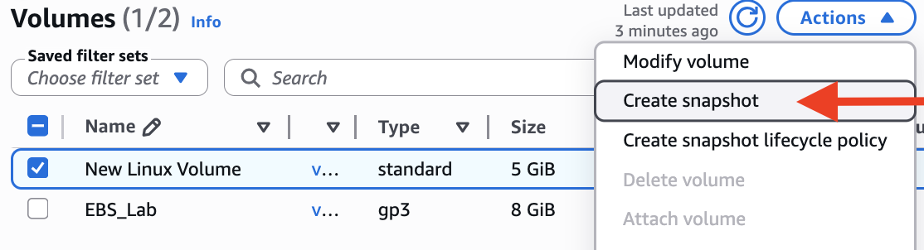
  - Give the snapshot some description you will remember. I put “Cloned_Linux”
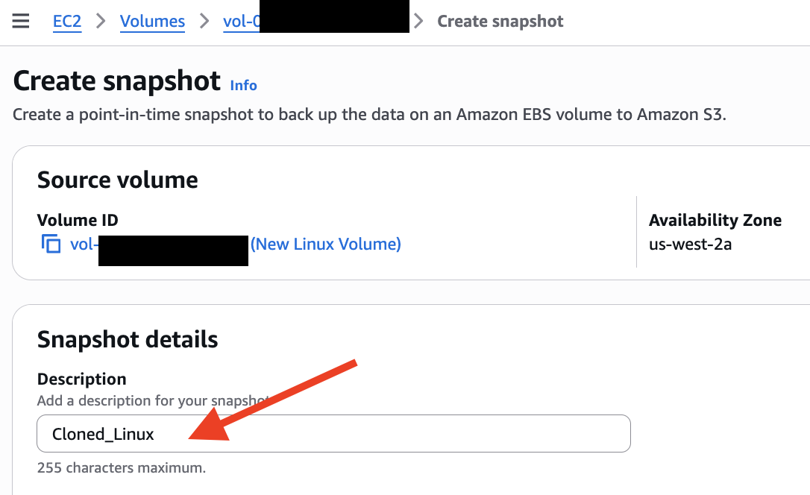
  - Click Create snapshot button to proceed.
  - Click Snapshots on the left menu under Elastic Block Store. You should see your snapshot being created.
  - Give it a name, such as “New Linux Volume SS”
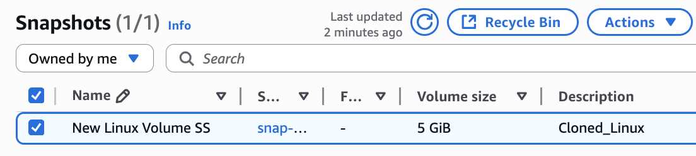
  - After your snapshot has been created (You need to wait till you see “Completed” as your snapshot Status)
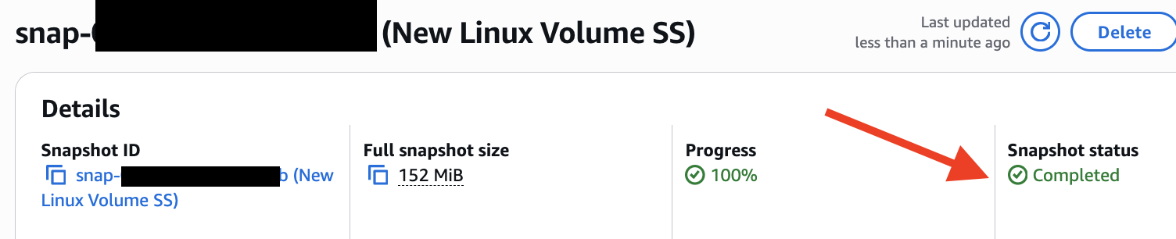
  - Go back Volumes and delete the volume you created.
    - Select “New Linux Volume” which is the one your created (NOT the one came along with your instance).
    - From the Actions button, select “Delete volume”.
  - Go back to Snapshots.
- Create a new volume from the snapshot.
  - Click the checkbox next to the snapshot you just made.
  - From the Actions button, select “Create volume from snapshot”.
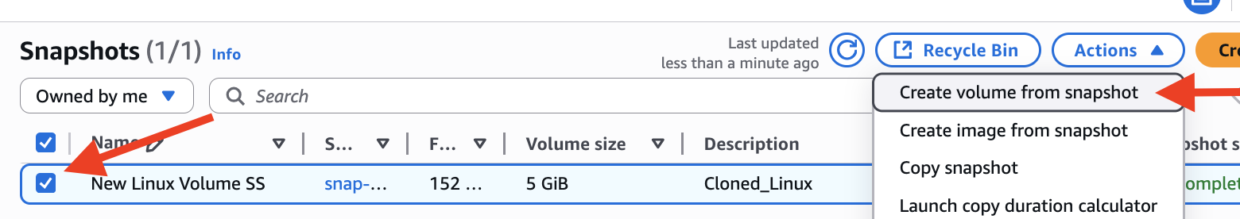
  - Select Volume type of “General Purpose SSD (gp3)”, if it’s not default.
  - Type “5” for Size(GiB), if it’s not default.
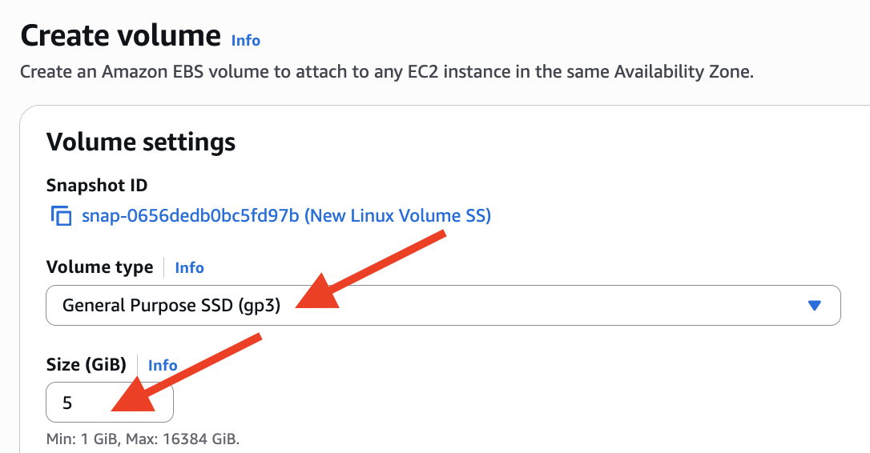
  - Make sure the volume is created in the same Availability Zone as your instance.
  - Click Create volume to proceed.
  - Go back to Volumes and attach the new volume to your Linux instance.
  - Get back into your SSH and remount the volume.
    - Run “lsblk” command to verify the device name (mine is same as before)
    - Run “file -s /dev/your_device_name” mine is file -s /dev/nvme1n1
    - Notice if is formatted with data. It should have a file system and contain your two files. Do NOT reformat the volume!
    - Mount the volume to the directory “fileserver” that you created earlier. Run “mount /dev/xvdf /fileserver”
    - “cd /fileserver”
    - Run “ls” Are your files still there? [They should be]
- Go to your instructor to get sign-off:
Note: If you got here outside of classtime, you should “Stop” your instance.
  - Show your instructor your “ls” result
  - Need to explain what did you do in Part I
- After getting signoff, you may terminate your EC2 instance.

Part II: Windows – RAID Volume
- What is RAID (Redundant Array of Independent Disks)? You are expected to explain this to your instructor later for the sign-off. You may put down some notes for your own reference. You may refer to Wikipedia: https://en.wikipedia.org/wiki/RAID
- Read this AWS article: https://docs.aws.amazon.com/AWSEC2/latest/WindowsGuide/raid-config.html
- Try to launch a Microsoft Windows Server 20xx Base (free tier eligible) instance.
Do NOT need to launch it.
- In “Network settings” section, go with all defaults.
- In “Configure Storage” section, add four (4) EBS volumes, each (8 GB) by clicking the “Add new volume” button. Accept the other defaults.
- Stop here – do NOT launch it
- Go to your instructor to get sign-off:
  - Need to explain what is RAID
  - Show your instructor any warning message your see for Free tier storage limit.

Part III: Create an AMI
You are creating an image that can be published to the public or shared with other people. AMIs are regional, but they can be copied to other regions. An AMI is a template for the root volume of an instance. Permissions related to the AWS accounts that can use the AMI are saved as part of the template. Block device mapping – volumes to attach to the instance – are also saved.
- Select your Snapshot (from Part I) and go Actions -> “Create image from snapshot”.
- Give the Image a Name, including your initial or last 3 digits of your A0 number. Accept the default values of the rest of the fields, and then click Create image button.
- On the lefthand side of your EC2 Dashboard, under Images, select AMIs.
Note: It may take several minutes before you see your AMI listed. Be patience!
You can always click the Refresh icon if you want to.
- Select the AMI and change AMI image permissions.
  - Click Actions -> “Edit AMI permissions”.
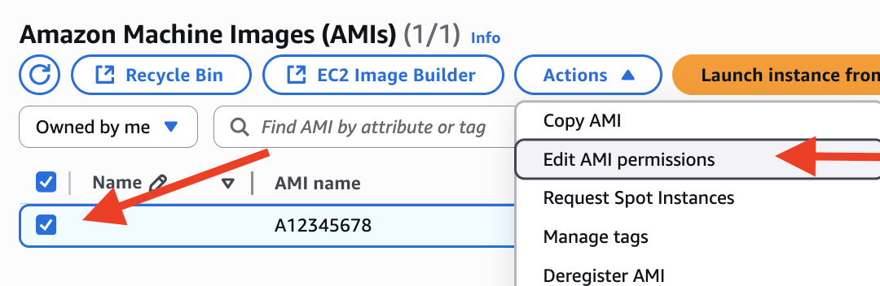
  - Leave the image Private.
  - In the section of shared accounts, use “Add account ID” button to share the image with your peer by entering THEIR AWS Account Number (ID), NOT your account number.
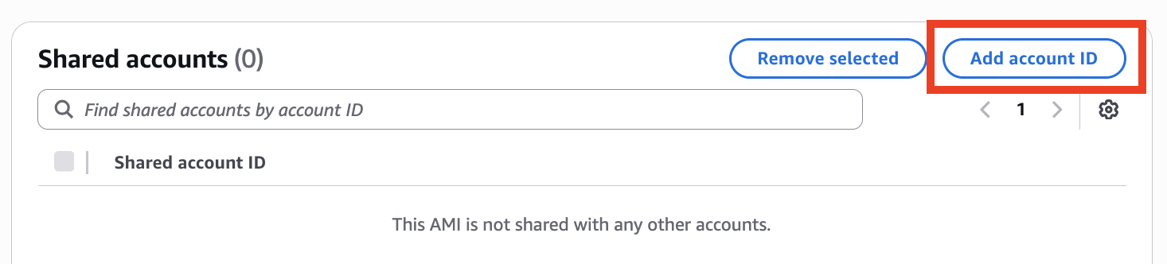
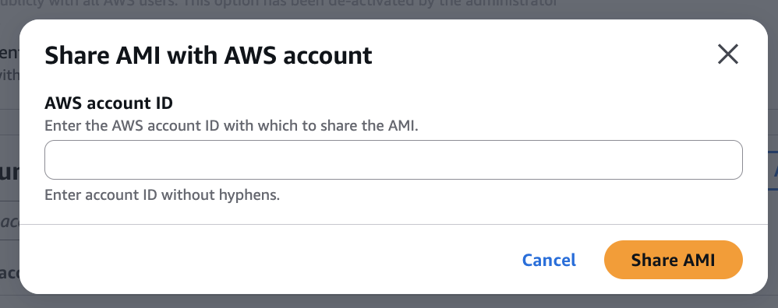
  - “Share AMI”.
  - If you are going to make your image public, please read the following information. You are NOT going to make your AMI public
http://docs.aws.amazon.com/AWSEC2/latest/UserGuide/building-shared-amis.html
  - Ask your peer to go to their EC2 Dashboard and click on AMIs under Images. Your peer should see your image and they can Launch an instance from that image. Click “My AMIs” (They don’t need to actually launch one.)
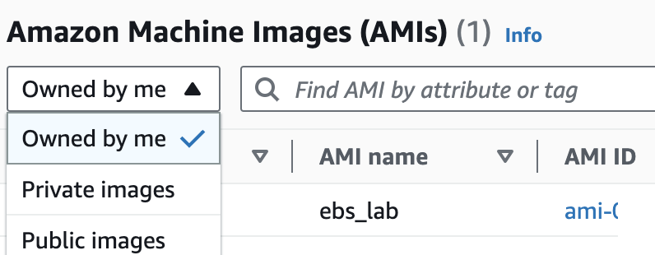
Stop here, invite your peer to go to your instructor, to get sign-off for you. – They need to prove they can see your AMI.

Part IV: AWS Instance Patching
In this part, we are creating an AMI as a temporary backup of the original instance prior to doing an upgrade. This is common procedure that is done when applying updates to a production Windows or Linux instance. It also applies when updating an application, such as a database, running on an instance. If the upgrade fails, then we can go back to our original image by launching the original instance from the AMI.
- If you don’t already have a running instance, then launch a Linux instance
  - Are volumes and snapshots automatically created?
- Create an AMI from an instance.
  - Select the instance.
  - From the Actions button, select “Image and templates” -> “Create Image”.
  - Name your image, name it “ebslabp4”
  - Scroll down to the bottom of the page, click Create image button to proceed.
- On the left hand side menu, under Images, select AMIs. It will take some time to create the AMI. Examine the image get created. This doesn’t happen when creating a new instance.
- SSH into the original instance. Update the original instance:
run “sudo yum update -y”
- Reboot the instance.
- SSH into the original instance and verify that Apache service is running.
  - To see if apache is running, type “ps aux | grep apache2”
- If the upgrade was successful, then Deregister the AMI.
- After the AMI has been deregistered, delete the Snapshots.
- Go to your instructor, show a screen of your “ps aux | grep apache2” result to get sign-off

Part V: AWS Instance Resizing
Instance resizing is the process of changing the Instance Type to a larger instance type. This means the workloads on an instance have increased and more memory and faster CPU is needed.
- Choose your Linux instance, stop it by selecting “Instance state” -> “Stop instance”.
- After the instance has stopped, go Actions -> “Instance settings” -> “Change instance type”.
- Select “t3.small” from the dropdown list of “Instance type” and click Apply button.
Note: Do NOT restart the instance to avoid cost.
- Sign-off:
Go to your instructor, show your EC2 dashboard with “t3.small” & “stopped” to get sign-off

Teardown
- Terminate all running instances.
- Deregister all AMIs. You will not be able to deregister your peer’s AMI, they need to do it. You may only deregister the AMIs you created. After you peer deregistering their AMI, you will not see it on your dashboard.
- Delete Snapshots.
- Delete all Volumes.
- Go to your instructor to get one last sign-off by showing all 4 above for teardown.

